*Mustang E13 Drill Rig*

**MUSTANG E13 MULTIPURPOSE DRILL RIG**

The Mustang E13 is a track mounted multipurpose drill rig which is highly effective on reverse circulation and diamond drilling especially when RC to DD switching time under consideration. At the time compared with other RC rigs its compact sizes allow to reach to hardest locations with 13 tons pull back and 13 tons torque capacity. This powerful drilling capacity also gives efficiency on water and geotechnical drilling even for piling.

**TECHNICAL SPECIFICATIONS**

***DEPTH CAPACITY***

|  |  |
| --- | --- |
| Core Drilling | Reverse Circulation |
| NQ Wireline 1.500,00 meter | 4 “ Rod 350,00 meter |
| HQ Wireline 1.100,00 meter | 5 “ Rod 260,00 meter |
| PQ Wireline 700,00 meter | |



*Mustang E13 Drill Rig*



***ENGINE***

|  |  |
| --- | --- |
| Type | Deutz Diesel BF6L 914 |
| Cooling System | Air |
| Rated Power | 165 hp |
| Torque | 550Nm @ 2300 r/min |
| Cylinder Volume | 6.472 dm³ |
| Number of Cyclinder | 6 |
| Canopy | Sound-proofing |

*Mustang E13 Drill Rig*



***ROTATION UNIT***

|  |  |
| --- | --- |
| Type | RH 130 |
| Rotation Speed | 8 gear, 0-655 r/min |
| Torque | 1300 daNm |

*Mustang E13 Drill Rig*

***FEED SYSTEM BMI 6.7***

|  |  |
| --- | --- |
| Length | 6.250 mm |
| Longitudinal Shift | 1.000 mm |
| Feed Beam Rotation | Not Applicable |
| Elevation | 0 - 90° |
| Free Travel Lenght | 6.700 mm |
| Feed and Retrac Force Max. | 130 kN ( 13 Tons) |
| Travel Speed ( Max. High speed) | 53 cm / sec |
| Travel Speed ( Max. High speed) | 27 cm / sec |

***CRAWLER***

|  |  |
| --- | --- |
| Crawler Track Lenght | 2.500 mm |
| Crawler Track Total Lenght | 3.715 mm |
| Track Width | 400 mm |
| Speed on Level Ground | 1,8 km/h |
| Climbing Angle | % 57 (30°) |

*Mustang E13 Drill Rig*



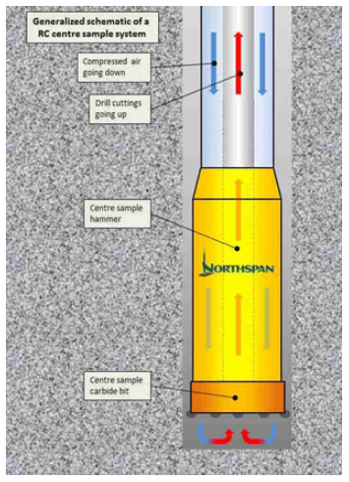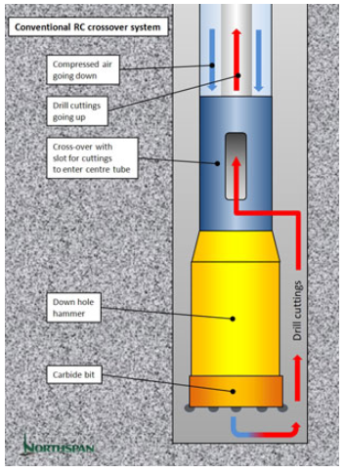

*Mustang E13 Drill Rig*

***WINCH***

|  |  |
| --- | --- |
| Pull Max. | 30kN |
| Max.Speed | 0,6 m/s |

***WIRELINE HOIST***

|  |  |
| --- | --- |
| Capacity Ø 6 mm Cable | 1200 m |
| Capacity Ø 5 mm Cable | 1450 m |
| Pull Max(empty drum) | 5,8 kN |
| Max.Speed (empty to full drum) | 3-5 m/s |

***WATER PUMP***

|  |  |
| --- | --- |
| Type | Trido 80 |
| Discharge Capacity | 75 l / min |
| Max. Discharge Pressure | 40 bar |

*Mustang E13 Drill Rig*

** **

***DRILL ROD BREAKER / HOLDER &GUIDE***

|  |  |
| --- | --- |
| Max.Opening | 300 mm. |
| Max.Grip force | 125 kN |
| Rotate Swing Angle | 18º |

*Mustang E13 Drill Rig*

***STANDART EQUIPMENT***

|  |
| --- |
| Turn Table |
| Rod Rack ( 50 each x 4 “ Rod 4,0 meter |
| 4 Hydraulic Jack |
| Hydraulic Mast Dump |
| Fuel Tank 120 L. |
| Hydraulic Mud Mixer |
| Cyclone |

